PHYS340 Design Exercise 1

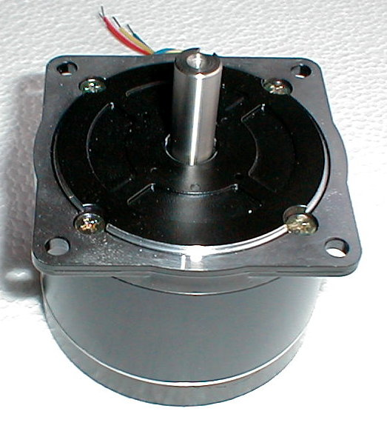

A GAL Based Stepper Motor Controller

David Harris
300069566

Summary

The design started with off with defining the states, and the logic needed to move from one to another. A state transition diagram was next constructed, and from that a state excitation table.

The next stage was to write the logic in the necessary way in WinCUPL. It was complied and tested with the WinSIM software. It was found to be correct, and so the 16V8B GAL was programmed.

The GAL was then wired up to the stepper motor and the necessary inputs. It was tested and found to be working correctly.

Introduction

The task for this experiment is to program a Programmable Logic Device to control a stepper motor. The basic functions that are needed are the ability to set the direction and the stepping mode. The possible combinations are either clockwise or anti-clockwise and half-step or full-step. When in the half-step mode, the motor turns 1°, and 2° when in full-step mode, when the correct logic was applied to the windings.

The stepper motor has four windings, which may be turned on and off, to make the motor turn. When power is applied to a specific winding, it asserts a magnetic force on the rotor, pulling it words the coil, in a circular fashion. Stepper motors are found in many everyday situations, for example floppy drives, flatbed scanners and printers. The stepper motor uses a Darlington Pair and TTL transistors to provide the 7.4V and 1.3A needed to drive the motor. The Darlington Pair is a single device that combines two bipolar junction transistors. The reason this is used is because the gain is very high and takes up less space than using two discrete transistors. The Darlington Pair is named after the inventor of the configuration, Sidney Darlington while working at Bell Labs.

To make the motor step forward (clockwise) in the half-step mode, the following logic has to be applied to the windings:

Step | W1 | W2 | W3 | W4
1 | 1 | 0 | 1 | 0
2 | 1 | 0 | 0 | 0
3 | 1 | 0 | 0 | 1
4 | 0 | 0 | 0 | 1
5 | 0 | 1 | 0 | 1
6 | 0 | 1 | 0 | 0
7 | 0 | 1 | 1 | 0
8 | 0 | 0 | 1 | 0

The task was to also make the stepper motor turn in the full-step mode. This is done by setting the same windings as before, but with half of the steps omitted. The logic is shown below:

Step | W1 | W2 | W3 | W4
1 | 1 | 0 | 1 | 0
3 | 1 | 0 | 0 | 1
5 | 0 | 1 | 0 | 1
7 | 0 | 1 | 1 | 0

Combining these combinations together with two inputs, for mode and direction was the task of the experiment.

Design Details

We are instructed to use the 16V8B GAL so there the only choice is how to implement the logic in the WINCUPL software package. There are two ways to implement the logic. One way is to take the logic from the state excitation table and minimize the logic for each input. Karnaugh maps can then be used to minimize the logic, but this can be time-consuming and mistakes can be made. The other option is to enter the data directly from the state transition diagram and let the computer work out the logic. I chose the latter method, as it is much quicker and easier for the computer to construct the logic.

The pin-out of the 16V8B GAL is shown below:

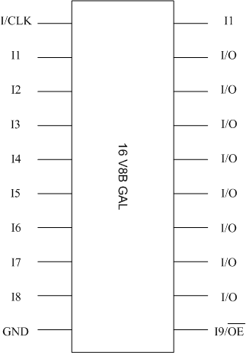

First of all, the individual state labels for the windings needs to chosen. These labels are chosen at random.

W4 | W3 | W2 | W1 | State
1 | 0 | 1 | 0 | 00
1 | 0 | 0 | 1 | 01
0 | 1 | 0 | 1 | 11
0 | 1 | 1 | 0 | 10

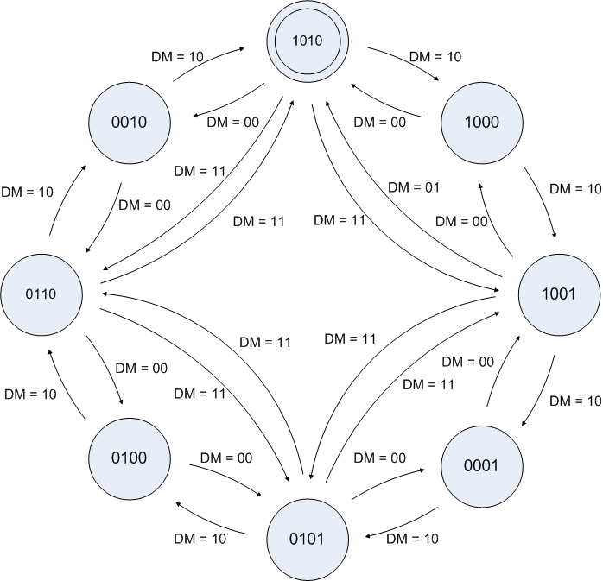
As mentioned above, I first constructed a state transition diagram. This is shown below:

This leads to the state excitation table, which determines the logic needed to make the stepper-motor move in the desired way. The table is shown below:

Inputs |  | Present |  | Next |  | Requires |  | Present
D | M | Q₁^{n} | Q₀^{n} | Q₁^{n+1} | Q₁^{n+1} | D₁ | D₀ | W4 | W3 | W2 | W1
0 | 0 | 0 | 0 | 0 | 0 | 0 | 0 | 1 | 0 | 1 | 0
0 | 0 | 0 | 1 | 0 | 1 | 0 | 1 | 1 | 0 | 0 | 1
0 | 0 | 1 | 0 | 1 | 0 | 1 | 0 | 0 | 1 | 1 | 0
0 | 0 | 1 | 1 | 1 | 1 | 1 | 1 | 0 | 1 | 0 | 1
0 | 1 | 0 | 0 | 0 | 0 | 0 | 0 | 1 | 0 | 1 | 0
0 | 1 | 0 | 1 | 0 | 1 | 0 | 1 | 1 | 0 | 0 | 1
0 | 1 | 1 | 0 | 1 | 0 | 1 | 0 | 0 | 1 | 1 | 0
0 | 1 | 1 | 1 | 1 | 1 | 1 | 1 | 0 | 1 | 0 | 1
1 | 0 | 0 | 0 | 1 | 0 | 1 | 0 | 1 | 0 | 1 | 0
1 | 0 | 0 | 1 | 0 | 0 | 0 | 0 | 1 | 0 | 0 | 1
1 | 0 | 1 | 0 | 1 | 1 | 1 | 1 | 0 | 1 | 1 | 0
1 | 0 | 1 | 1 | 0 | 1 | 0 | 1 | 0 | 1 | 0 | 1
1 | 1 | 0 | 0 | 0 | 1 | 0 | 1 | 1 | 0 | 1 | 0
1 | 1 | 0 | 1 | 1 | 1 | 1 | 1 | 1 | 0 | 0 | 1
1 | 1 | 1 | 0 | 0 | 0 | 0 | 0 | 0 | 1 | 1 | 0
1 | 1 | 1 | 1 | 1 | 0 | 1 | 0 | 0 | 1 | 0 | 1

The next step was to decide how to implement the logic. As stated above I chose to input the data from the state transition diagram directly into the WinCUPL software. The source code is in the appendices.

The first section sets up the data that the compiler needs to burn the chip, the most important of which is the device field. This is needed so the compiler can look up the library of chips and check if what you have specified is allowed. Next the inputs pins are specified as the clock, direction, mode and output enable. The four output pins that go to the stepper-motor are next enabled as pins 14 to 17. The states are then defined to make it easier and shorter to type. Next the different modes are defined; they are upHalf, upFull, downHalf and downFull.

Now the part comes when the logic is actually written down. Here the previously mentioned defined states are used. It basically says that if you are this state then the next state will be that state. This is taken directly off the state transition diagram above.

Once this source code is compiled, some files are created that the computer uses to actually burn and test the chip. The .doc file shows the logic that was created and also the table of what pins are what. This is very useful when wiring up the chip. The .doc is also in the appendices.

As part of the WinCUPL software package is the simulator WinSIM. This simulates the operation of the chip before it is burnt to make sure that the logic is correct, and operates how is expected. The control signals such as direction and mode can be set, while the outputs Q3 to Q0 are simulator determined. This can save a lot of time as it can be easily determined if the logic is incorrect.

The next stage was to actually burn the chip using the .jed file that it creates. Once the chip is burnt, the control signals and outputs were connected. Q0 to Q3 are connected to the windings of the stepper motor.

The pit-out diagram of the programmed GAL is shown below:

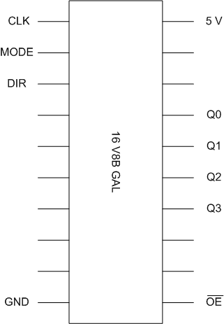

Performance

The stepper-motor controller testing was two-fold. It was first tested with the WinSIM software, and was found to be working perfectly. Next was the real testing of the chip itself. The clock, direction and mode inputs were connected to logic switches. The outputs Q0 to Q3 were connected to the stepper-motor. Power and ground were next connected, and the circuit was turned on. It was tested extensively, with all possible combinations of inputs tried, as well as changing them at different times and orders. The stepper-motor was found to be working as expected throughout all tests.

Conclusions

The project was successful and it was found that it is possible to create simple stepper-motor controller cheaply and easily. The most difficult part was creating the state transition diagram, but overall it was a quick process. This was made possible because I chose to program the GAL directly off the state transition diagram, rather than minimizing the logic myself. If I chose to minimize the logic, it would have taken a lot longer and there is much more room for human error.

My design worked flawlessly in all tests, both simulated and actual tests.

References and Bibliography

- http://www.jdr.com/interact/item.asp?itemno=gr-16v8
Used to find the price of a 16V8B GAL

- PHYS234 Laboratory Manual, Experiment 9
Used to look up details of and the 16V8B GAL chip, and the WinCUPL software.

- http://www.machinetoolcamp.com/images/Large%20Stepper%20Motor.JPG
Used for the photo on the title page

Appendices

Section | Page
Parts list and cost | 12
Source code (.pld) | 13
Post-compile information (.doc) | 15

Parts list and cost

The required parts are:
- 1 Amtel AFT16V8B GAL IC
- Computer
  - WinCUPL
  - WINSIM
  - IC burning hardware and software
- Stepper motor
- PHYS200 level Student Design Station

The total cost of the chip is a US$2.50, or NZ$3.50.

Source code

Name PHYS340 ;
PartNo 00 ;
Date 5/05/2005 ;
Revision 01 ;
Designer David Harris ;
Company VUW ;
Assembly None ;
Location VUW ;
Device G16V8A ;

/* *************** INPUT PINS *********************/
PIN 1 = clk; /* Counter clock*/
PIN 2 = mode; /* Mode, fullstep or halfstep*/
PIN 3 = dir; /* Direction, clockwise or anti-clockwise*/
PIN 11 = !oe; /* Output enable*/

/* *************** OUTPUT PINS *********************/
PIN [14..17] = [Q3..0];

field count = [Q3..0];
$define S0 'b'1010
$define S1 'b'1000
$define S2 'b'1001
$define S3 'b'0001
$define S4 'b'0101
$define S5 'b'0100
$define S6 'b'0110
$define S7 'b'0010

$define S8 'b'0000
$define S9 'b'0011
$define S10 'b'0111
$define S11 'b'1011
$define S12 'b'1100
$define S13 'b'1101
$define S14 'b'1110
$define S15 'b'1111

field state = [mode, dir]; /* Define state control field*/
upFull = state:3; /*define upFull*/
downFull = state:2; /*define downFull*/
upHalf = state:1; /*define upHalf*/
downHalf = state:0; /*define downhalf*/

Sequenced count {

present S0 if upFull next S2;
if downFull next S6;
if upHalf next S1;
if downHalf next S7;

present S1 if upFull next S2;
if downFull next S0;
if upHalf next S2;
if downHalf next S0;

present S2 if upFull next S4;
if downFull next S0;
if upHalf next S3;
if downHalf next S1;

present S3 if upFull next S4;
if downFull next S2;
if upHalf next S4;
if downHalf next S2;

present S4 if upFull next S6;
if downFull next S2;
if upHalf next S5;
if downHalf next S3;

present S5 if upFull next S6;
if downFull next S4;
if upHalf next S6;
if downHalf next S4;

present S6 if upFull next S0;
if downFull next S4;
if upHalf next S7;
if downHalf next S5;

present S7 if upFull next S0;
if downFull next S6;
if upHalf next S0;
if downHalf next S6;

present S8 next S0;
present S9 next S0;
present S10 next S0;
present S11 next S0;
present S12 next S0;
present S13 next S0;
present S14 next S0;
present S15 next S0;

}

Post-Compile Information

*********************************************************************
PHYS340
*********************************************************************

CUPL(WM) 5.0a Serial# 60008009
Device g16v8ms Library DLIB-h-40-11
Created Thu May 05 16:35:56 2005
Name PHYS340
Partno 00
Revision 01
Date 5/05/2005
Designer David Harris
Company VUW
Assembly None
Location VUW

=====================================================================
Expanded Product Terms
=====================================================================

Q0.d =>
Q0 & !Q1 & !Q2 & !Q3
# !Q1 & !Q2 & Q3 & dir
# !Q1 & Q2 & !Q3 & !dir
# !Q0 & !Q2 & Q3 & dir & mode
# !Q0 & Q2 & !Q3 & !dir & mode

Q1.d =>
Q0 & Q1
# Q2 & Q3
# !Q0 & !Q3 & dir
# !Q0 & !Q2 & !dir
# Q2 & dir & mode
# Q3 & !dir & mode

Q2.d =>
!Q0 & !Q1 & Q2 & !Q3
# Q0 & !Q1 & !Q3 & dir
# !Q0 & Q1 & !Q3 & !dir
# Q0 & !Q1 & !Q2 & dir & mode
# !Q0 & Q1 & !Q2 & !dir & mode

Q3.d =>
Q0 & Q1
# Q2 & Q3
# !Q0 & !Q2 & dir
# !Q1 & !Q2 & !dir
# Q1 & dir & mode
# Q0 & !dir & mode

count =>
Q3 , Q2 , Q1 , Q0

downFull =>
!dir & mode

downHalf =>
!dir & !mode

state =>
mode , dir

upFull =>
dir & mode

upHalf =>
dir & !mode

=====================================================================
Symbol Table
=====================================================================

Pin Variable Pterms Max Min
Pol Name Ext Pin Type Used Pterms Level
--- -------- --- --- ---- ------ ------ -----

Q0 17 V - - -
Q0 d 17 X 5 8 2
Q1 16 V - - -
Q1 d 16 X 6 8 2
Q2 15 V - - -
Q2 d 15 X 5 8 2
Q3 14 V - - -
Q3 d 14 X 6 8 2
clk 1 V - - -
count 0 F - - -
dir 3 V - - -
downFull 0 I 1 - -
downHalf 0 I 1 - -
mode 2 V - - -
! oe 11 V - - -
state 0 F - - -
upFull 0 I 1 - -
upHalf 0 I 1 - -

LEGEND D : default variable F : field G : group
I : intermediate variable N : node M : extended node
U : undefined V : variable X : extended variable
T : function

